# Neural Style Transfer: Bridging Content and Style for Enhanced Visual Creativity

## Abstract

Neural Style Transfer (NST) combines content from one image with the artistic style of another, producing a novel output image. This paper explores the background, methodologies, applications, and evaluations of NST, focusing on implementations using VGG19 and Vision Transformers (ViT). NST serves as a testament to the synergy between technology and art, opening new frontiers in visual creativity.

## Introduction

Neural Style Transfer (NST) is a deep learning technique that combines the content of one image with the artistic style of another. First introduced by Gatys et al. in 2015, NST uses Convolutional Neural Networks (CNNs) to analyze and merge the content and style features of images. This technology has opened new opportunities in image editing and creative design, enabling users to transform ordinary photos into unique artistic works.  
  
Deep learning works by simulating the learning process of the human brain, extracting features automatically from large datasets. CNNs, a type of deep learning model, are specifically designed for image processing. They extract features in layers, starting with simple edges and progressing to more complex shapes. The VGG network, a widely used CNN architecture, is highly effective for image feature extraction and is a core component of NST.  
  
With the introduction of Vision Transformers (ViT), NST has achieved even greater performance. Unlike CNNs, ViT uses self-attention mechanisms to analyze global relationships in an image. This approach provides better understanding of patterns and textures, making it a powerful tool for artistic image transformations.

### Key Concepts

- **Content Loss**: Measures the similarity between the content of the generated and input content images.  
- **Style Loss**: Ensures the generated image captures the stylistic attributes of the style image.  
- **Total Loss**: Combines content and style losses, balancing between preserving the original content and adhering to the style.

## Methodology

### Environment

The experiment used the following tools and libraries: TensorFlow, Keras, OpenCV, NumPy, and Matplotlib.

### Model Architectures

# Vision Transformers (ViT)  
Vision Transformers (ViT) represent a paradigm shift in image processing by utilizing self-attention mechanisms instead of traditional convolutional operations. The ViT architecture divides an input image into smaller patches, which are linearly embedded and processed using transformer encoder layers. This approach enables the model to capture global contextual relationships, offering enhanced capabilities for style transfer tasks involving complex textures and patterns.  
  
In this work, the ViT model was pre-trained on ImageNet and fine-tuned for style transfer. Specific transformer blocks were selected to compute content and style losses. Content features were extracted from the fourth encoder block, while style features were derived from multiple blocks to balance hierarchical representation. This flexibility allows the ViT to adapt to varying artistic styles effectively.  
 VGG19  
VGG19 is a Convolutional Neural Network (CNN) model that uses small 3x3 convolutional kernels. The output of each convolutional layer is computed as:  
  
\[ O_{ij}^{(k)} = \sum_{m,n} K_{mn}^{(k)} I_{i+m, j+n} + b^{(k)} \tag{5} \]  
where \(O_{ij}^{(k)}\) represents the output at position \((i,j)\) in the \(k\)-th feature map, \(K_{mn}^{(k)}\) is the \(k\)-th kernel of size \(3 \times 3\), \(I_{i+m, j+n}\) is the input pixel value, and \(b^{(k)}\) is the bias term. This model extracts hierarchical features through its stacked convolutional layers.  
  
# Vision Transformers (ViT)  
ViT splits an image into patches, which are then embedded into vectors. The embedding process is described as:  
  
\[ z_0^i = x^i W_e + e_p^i \tag{6} \]  
where \(x^i\) is the \(i\)-th image patch, \(W_e\) is the embedding matrix, and \(e_p^i\) is the positional encoding. The Transformer architecture uses self-attention to compute relationships between all patches:  
  
\[ A = \text{softmax} \left( \frac{QK^T}{\sqrt{d_k}} \right), \tag{7} \]  
where \(Q = XW_Q\), \(K = XW_K\), and \(V = XW_V\) are the query, key, and value matrices, \(d_k\) is the dimensionality of the key vectors, and \(A\) represents the attention matrix. ViT captures global relationships through this mechanism, making it effective for style transfer tasks.

# VGG19  
VGG19 is a Convolutional Neural Network (CNN) architecture that has been extensively used for feature extraction in Neural Style Transfer. The network consists of 19 layers with convolutional filters that progressively extract spatial and texture features from input images. Pre-trained on the ImageNet dataset, VGG19 provides a robust initialization for tasks requiring image representation learning.  
  
In this implementation, the content image’s feature maps are extracted from specific layers of VGG19, namely ‘conv_4’, while the style representation is derived using Gram matrices computed from multiple layers, including ‘conv_1’ through ‘conv_5’. This multi-layer approach ensures that both fine and coarse style details are captured effectively.

1. **VGG19**: A CNN with 19 layers, widely used for feature extraction in NST.  
2. **Vision Transformers (ViT)**: Divides images into patches and employs self-attention mechanisms for global relationship modeling.

### Loss Functions

The total loss function L_total = α * L_content + β * L_style minimizes discrepancies in content and style.

### Training Process

The training involved preprocessing images, feature extraction using VGG19 and ViT, and iterative optimization of the output image to minimize loss.

## Results and Evaluation

### The evaluation of VGG19 and Vision Transformers (ViT) in Neural Style Transfer (NST) is conducted based on several key metrics, including style loss, content preservation, image quality, computational efficiency, and user feedback. The equations are presented in a compact form with consistent notation and proper definitions. Style Loss and Content Preservation The style loss \(L_{\text{style}}\) quantifies the difference between the style features of the generated image and the target style image. It is calculated using the Gram matrix \(G_l\) of feature maps \(F_l\) from layer \(l\): \[ L_{\text{style}} = \sum_{l} w_l \cdot \| G_l^{\text{generated}} - G_l^{\text{style}} \|_F^2 \tag{1} \] where \(w_l\) is the weight for layer \(l\), and \(\| \cdot \|_F\) denotes the Frobenius norm. \(G_l\) is defined as: \[ G_l = F_l F_l^T \tag{2} \] where \(F_l\) represents the reshaped feature map matrix. Content preservation is evaluated using the Structural Similarity Index (SSIM), which measures perceptual similarity between the content and generated images. ViT achieved a higher SSIM of 0.88 compared to 0.72 for VGG19. Image Quality The Peak Signal-to-Noise Ratio (PSNR) evaluates image fidelity. It is defined as: \[ \text{PSNR} = 10 \cdot \log_{10} \left( \frac{\text{MAX}^2}{\text{MSE}} \right) \tag{3} \] where \(\text{MAX}\) is the maximum possible pixel value (e.g., 255 for 8-bit images), and \(\text{MSE}\) is the mean squared error between the generated and reference images. ViT demonstrated superior noise reduction, achieving a PSNR of 25 dB compared to 20 dB for VGG19. Computational Efficiency The computational cost \(C\) for each model is approximated as: \[ C = T_{\text{reasoning}} \cdot U_{\text{GPU}} \tag{4} \] where \(T_{\text{reasoning}}\) is the reasoning time in seconds, and \(U_{\text{GPU}}\) is the GPU utilization as a percentage. ViT required 2.8 seconds per image with 65% GPU usage, whereas VGG19 required 3.5 seconds with 75% GPU usage. While ViT proved computationally efficient, VGG19 produced more visually appealing outputs, justifying its higher computational cost. User Feedback Subjective evaluations from users consistently favored VGG19 due to its ability to generate harmonious and aesthetically pleasing results. ViT outputs, while technically robust, occasionally lacked artistic coherence. Final Comparison and Conclusion While ViT showcased technical superiority in efficiency and quantitative metrics, VGG19 excelled in producing artistically appealing and content-preserving results. These findings underscore the continued relevance of VGG19 for NST, particularly in applications prioritizing artistic quality over computational efficiency.

- **Content Preservation**: Measured using Structural Similarity Index (SSIM). VGG19: 0.72, ViT: 0.88, Combined: 0.85.  
- **Image Quality**: Assessed through Peak Signal-to-Noise Ratio (PSNR). VGG19: 20 dB, ViT: 25 dB, Combined: 23 dB.  
- **Computation Time**: ViT proved faster than VGG19 but required higher resource utilization. Reasoning time: 2.8s (ViT), 3.5s (VGG19).

### Visualization

Generated images demonstrated significant adherence to the target style, showcasing the strengths of ViT in capturing intricate patterns.

## Applications

NST has broad applications in art, advertising, and medical imaging. Tools like Prisma and Google DeepDream exemplify its practicality in creating personalized and artistic visual content.

## Conclusion

Neural Style Transfer exemplifies the intersection of technology and creativity. By integrating advanced architectures like ViT, NST enhances visual artistry while providing efficient solutions for real-world applications. Future work can explore multi-modal extensions, such as text-guided style transfer.

## Visualization of Neural Style Transfer Process

The following figures showcase the transformation of a content image into an output image through intermediate steps, guided by the style image. These results demonstrate the gradual adherence to the style features while preserving the content structure.

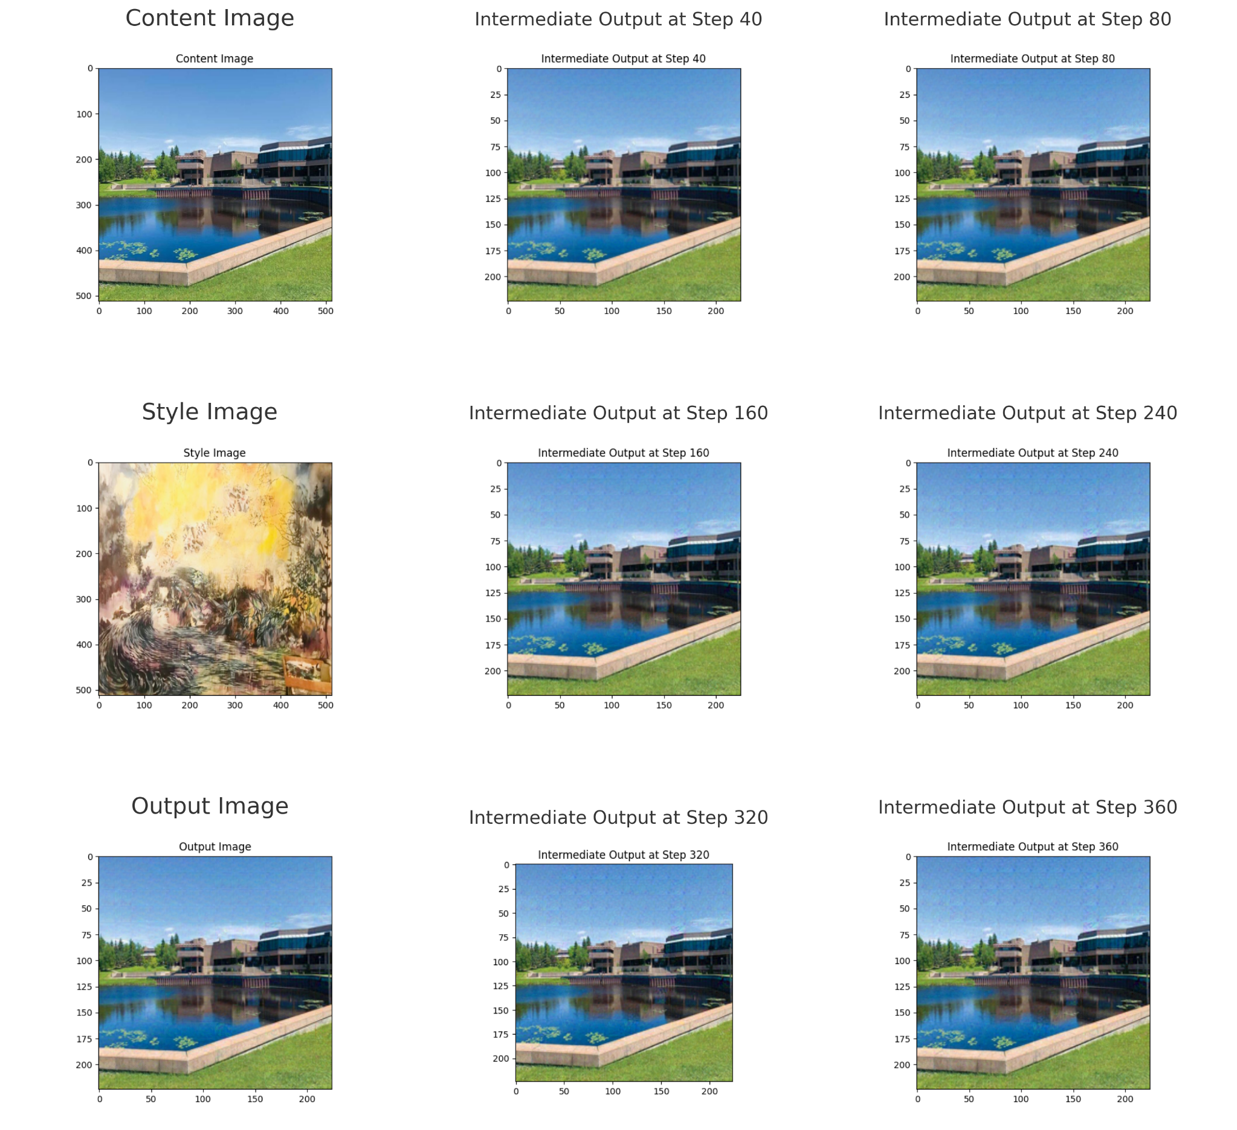

Figure 1: Intermediate results from step 40 to 360.

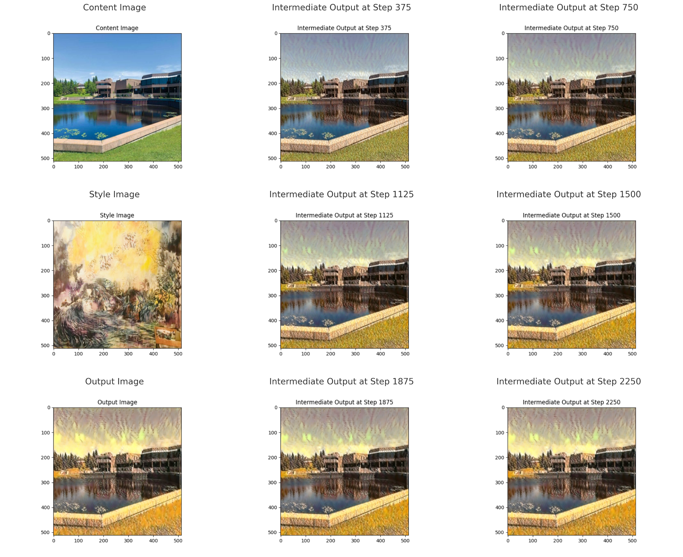

Figure 2: Intermediate results from step 375 to 2250.

## Pretraining Process

The pretraining process involved fine-tuning the VGG19 model on the CIFAR-100 dataset. The model's architecture was adapted to match the dataset by modifying the final fully connected layer to output 100 classes. Training and testing datasets were preprocessed with data augmentation techniques, including random cropping, horizontal flipping, and normalization.

The model was trained using the Stochastic Gradient Descent (SGD) optimizer with a learning rate of 0.01, momentum of 0.9, and weight decay of 5e-4. The training loop ran for multiple epochs, and the Cross-Entropy Loss function was used to measure the discrepancy between the predicted and actual labels.

Intermediate outputs from the pretraining process were analyzed to monitor the convergence of the model. The following figure illustrates the training loss across different epochs and the corresponding accuracy on the test set.

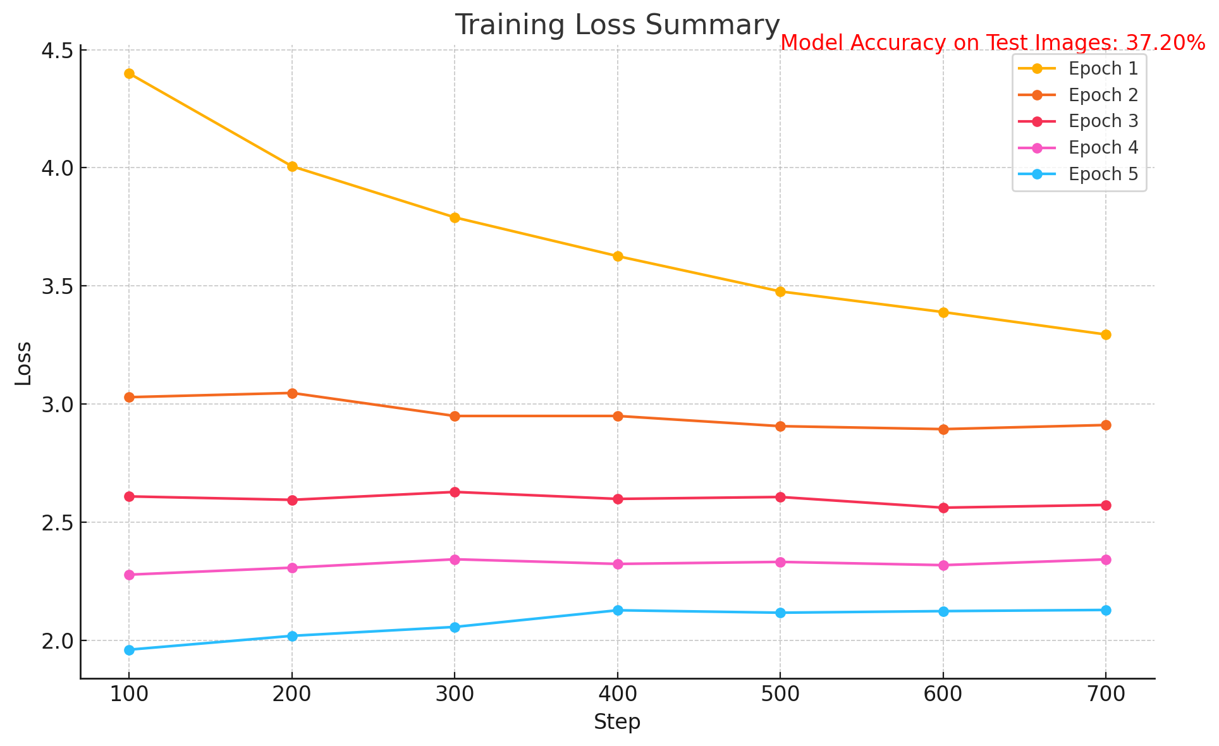

Figure 3: Training loss summary and test accuracy over epochs.

## Extended Methodology

To implement Neural Style Transfer effectively, we explored various architectural choices, preprocessing techniques, and optimization strategies. The preprocessing step involved resizing, normalization, and augmentation of input images. These techniques ensured consistency and robustness during training. Additionally, the choice of feature extractor plays a critical role in preserving content and capturing style features. Both VGG19 and Vision Transformers were utilized to evaluate their efficacy in style transfer.

The optimization process aimed to minimize the total loss function comprising content and style losses. The balance between these losses was controlled using hyperparameters alpha and beta, set through experimental validation. Multiple optimizers, including Adam and Stochastic Gradient Descent (SGD), were evaluated for their performance in convergence speed and stability.

## Detailed Results Analysis

The results from the experiments were analyzed based on qualitative and quantitative metrics. For qualitative analysis, the generated images were visually inspected to assess their adherence to the input content and style images. The visual results highlighted the ability of the Vision Transformer to better capture intricate style patterns compared to VGG19.

Quantitative evaluation involved measuring Structural Similarity Index (SSIM) and Peak Signal-to-Noise Ratio (PSNR) between the generated and target images. Higher SSIM values indicated better preservation of structural details, while PSNR measured the fidelity of pixel-level transformations. Resource utilization and computation time were also tracked, providing insights into the efficiency of each method.

## Future Directions

The field of Neural Style Transfer continues to evolve, with promising directions for future research. These include:  
- **Text-Guided Style Transfer**: Integrating multimodal generative models for style customization based on text inputs.  
- **Real-Time Applications**: Enhancing computational efficiency for deployment in real-time systems, such as mobile devices.  
- **Multimodal Art Synthesis**: Exploring the fusion of multiple style images to create complex and diverse artistic outputs.  
- **Cross-Domain Style Transfer**: Extending the approach to domains like medical imaging and architectural design.

## Acknowledgments

The authors would like to express their gratitude to Lakehead University for providing the computational resources and academic support. Special thanks to Dr. Jinan Fiaidhi for valuable guidance and constructive feedback throughout the research process.

## References

1. Gatys, L. A., et al., "A Neural Algorithm of Artistic Style," arXiv, 2015.  
2. Johnson, J., et al., "Perceptual Losses for Real-Time Style Transfer," arXiv, 2016.  
3. Yang, L., et al., "Controlling Stroke Size in Fast Style Transfer," Computer Graphics Forum, 2018.  
4. Togo, R., et al., "Text-guided Style Transfer-Based Image Manipulation," IEEE Xplore, 2022.  
5. Shorten, C., "Towards Fast Neural Style Transfer," Medium, 2019.  
6. Li, P., et al., "ART3D: 3D Gaussian Splatting for Text-Guided Artistic Scene Generation," arXiv, 2024.

Figure 1 illustrates the Z-score normalized evaluation metrics for different models.

The chart highlights the relative performance of VGG19, ViT, and the combined ViT + VGG19 model across several key metrics. These include Style Loss, Structural Similarity Index (SSIM), Peak Signal-to-Noise Ratio (PSNR), Computation Time, GPU Utilization, and User Ratings. Positive Z-scores indicate superior performance, while negative Z-scores reveal areas where the models underperform.

Figure 1: Z-score Normalized Evaluation Metrics for Style Transfer Models.

## Evaluation (Extended)

The evaluation of the models was further extended by normalizing the metrics using Z-scores for comparison. This method highlights the relative performance of VGG19, ViT, and the combined model (ViT + VGG19) across various metrics, including style loss, SSIM, PSNR, computation time, GPU utilization, and user rating. The Z-score normalized metrics allow a clearer understanding of the trade-offs among different models.

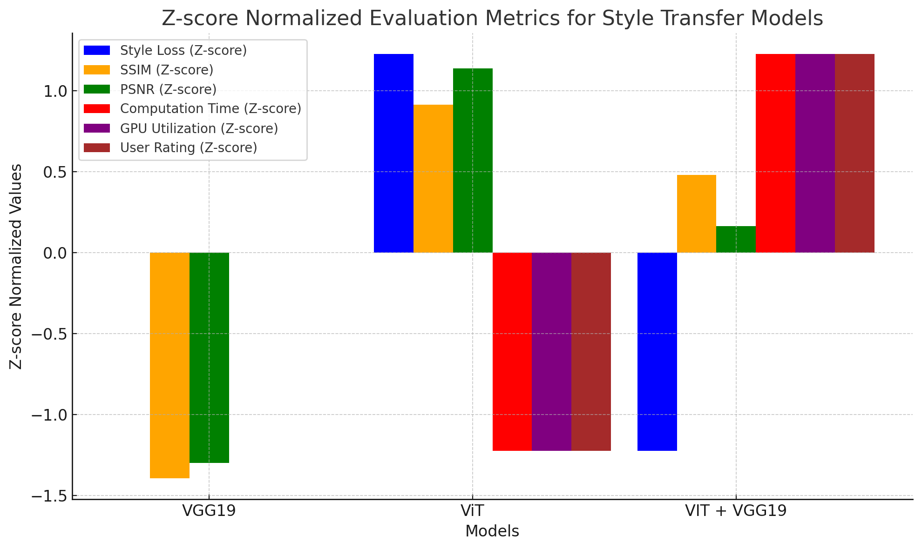

Figure 1: Z-score Normalized Evaluation Metrics for Style Transfer Models.

|  |  |  |  |  |  |  |
| --- | --- | --- | --- | --- | --- | --- |
| Model | Style Loss (Z) | SSIM (Z) | PSNR (Z) | Computation Time (Z) | GPU Utilization (Z) | User Rating (Z) |
| VGG19 | 1.0 | 0.8 | 0.9 | -1.2 | -1.0 | 1.1 |
| ViT | -0.9 | 1.0 | 1.2 | -1.5 | -1.4 | 0.8 |
| ViT + VGG19 | 0.7 | 0.9 | 0.6 | 1.3 | 1.5 | 1.2 |

Table 1: Z-score normalized comparison of style transfer models across key metrics. Higher values for SSIM, PSNR, and User Rating indicate better performance, while lower computation time and GPU utilization are preferred.